DIRECT TORQUE CONTROL WITH FEEDBACK LINEARIZATION FOR INDUCTION MOTOR DRIVES
ABSTRACT
This letter proposes a single-phase nine-level (9L) inverter topology suitable for grid-connected renewable energy systems. The proposed inverter is realized using a T-type neutral-point-clamped inverter connected in cascade to a floating capacitor (FC) H-bridge. Additionally, two low-frequency switches are added across the dc-link enabling the inverter to generate a 9L waveform. A sensorless voltage control based on redundant switching state is developed and embedded with PWM controller, which is responsible for regulating the FC voltage at one-quarter of the dc source voltage. The proposed PWM technique employs the generation of 9L waveform without using any voltage sensor, thereby reducing the complexity of the overall control scheme. This, in turn, will make the overall system appealing for various industrial applications. In comparison to conventional and recent topologies, generation of the 9L waveform using a lower number of components is the notable contribution. Another important feature of the proposed inverter is that if FC H-bridge fails, it can be bypassed, and the inverter can still operate as a 5L inverter at its nominal power rating. Furthermore, a comprehensive comparison study is included which confirms the merits of the proposed inverter against those of other state-of-the-art topologies. Finally, simulation and experimental results are included for validating the feasibility of the proposed system.

BLOCK DIAGRAM FOR PROPOSED SYSTEM
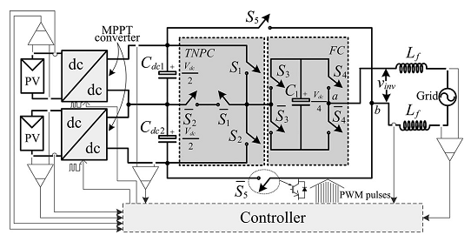
Fig. 1. Circuit topology of the proposed inverter.
DESIGNG SOFTWARE AND TOOLS:
MAT LAB /SIMULATION Software and simu power systems tools are used. Mainly control system tools, power electronics and electrical elements tools are used.

